# Assembly Guide for Ardumoto Shield with Shadow Chassis and Arduino 101

Introduction

This guide describes the assembly of the [Shadow Chassis](https://www.sparkfun.com/products/13301) and the Ardumoto Shield with an Arduino 101. It is an adaption of the guide for the Sparkfun RedBot.

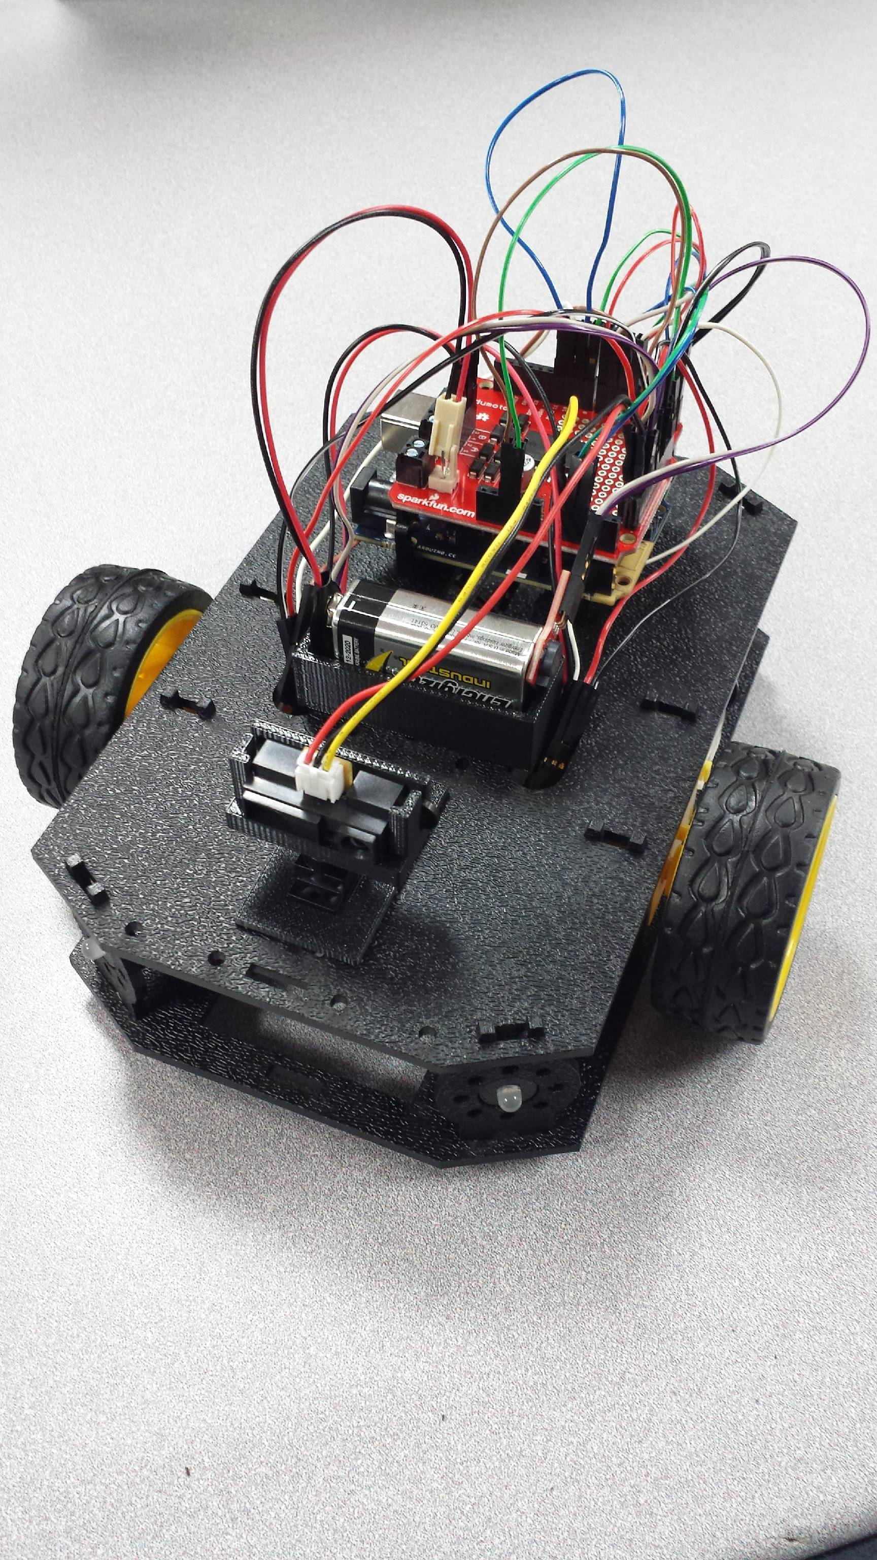

Ardumoto Overview

Pins and Connectors

Here’s an annotated view of the shield, highlighting the important pins and components:

[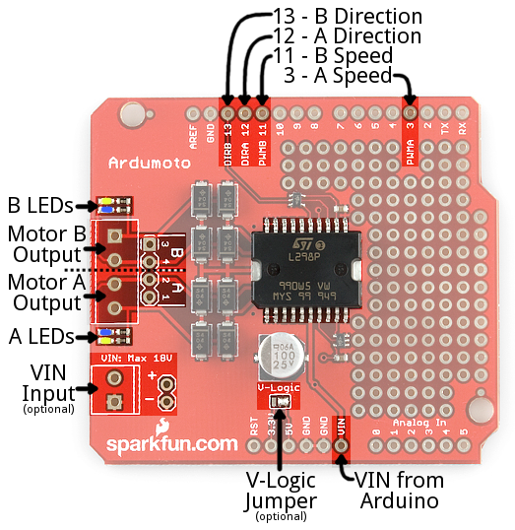](https://cdn.sparkfun.com/assets/b/8/6/c/2/527c0c05757b7fc33c8b4567.png)

The Ardumoto Shield lays claim to four Arduino pins: 3, 11, 12, and 13. Each motor uses two pins – one for **direction**, the other controls the **speed**.

|  |  |  |
| --- | --- | --- |
| **Arduino Pin** | **Ardumoto Shield Pin Label** | **Notes** |
| 3 | PWM A | A PWM signal to control the speed of motor A. 0=off, 255=max speed. |
| 11 | PWM B | A PWM signal to control the speed of motor B. 0=off, 255=max speed. |
| **Arduino Pin** | **Ardumoto Shield Pin Label** | **Notes** |
| 12 | DIR A | A digital signal to control the rotation direction of motor A (e.g. HIGH/LOW => CW/CCW). |
| 13 | DIR B | A digital signal to control the rotation direction of motor B (e.g. HIGH/LOW => CW/CCW). |

While the Ardumoto Shield is attached to an Arduino, these pins **shouldn’t be connected to anything else**.

Since we will be using the Arduino 101 board, we will need to jump from pin 11 to pin 9 for PWM B control.

Motor Outputs

Both of the L298’s motor driver outputs are broken out to the left-edge of the shield. Use the **0.1"-pitch header** to wire up your motor, to make life much easier if you need to disconnect your motor. The L298 is perfect for building simple 2 wheel drive robot platforms – connect one motor to port A and the other motor to port B.

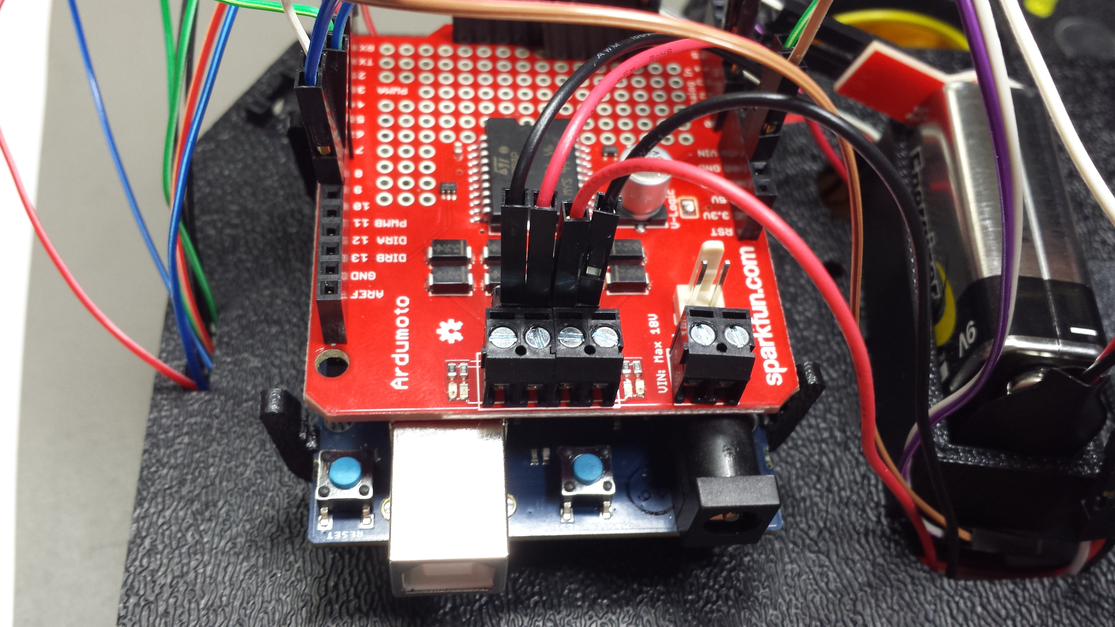

Technically, there is no right or wrong way to connect your motor’s wires to the two output pins, but to help keep things straight, we suggest connecting the red / black wire for each motor to pins 1 / 2 on port A and pin 3 / 4 on port B, respectively.

Don’t worry if you swap this, the direction control of the motor will just be swapped as well.

LED Indicators

Next to each of the motor outputs are a pair of blue and yellow LEDs, which **indicate the direction** your motor is spinning. These are great once you get to debugging your project. They’re also useful if you want to test your sketch without wiring up any motors.

Supply Voltage

The Ardumoto Shield should be powered through one of two power supply inputs. Pick **one or the other**:

1. The **barrel jack** input on the Arduino.
2. The **VIN input** on the shield. We will be using this input for power with a 9V battery.

If you don’t want to use the Arduino’s barrel jack input, you can use the **VIN input on the shield** instead. This voltage input will supply **both the shield and the Arduino**. Like the motor outputs, this connection is broken out to both a 3.5mm screw terminal and a 0.1"-pitch header, we will use the header to connect to the 9V battery.

Do not supply power to *both* the Arduino barrel jack input and VIN on the shield!

Materials

The SparkFun Ardumoto Shield, Shadow Chassis and Arduino 101 Kit contains the following pieces.

**X**

**W**

**V**

**U**

**Y**

**Z**

**T**

**S**

**R**

**Q**

**P**

**O**

**N**

**M**

**L**

**K**

**J**

**I**

**H**

**G**

**F**

**E**

**D**

**C**

**B**

**A**

|  |  |  |
| --- | --- | --- |
|  | **Part** | **Qty** |
| A | Bottom Chassis Plate | 1 |
| B | Top Chassis Plate | 1 |
| C | Front Motor Mount | 2 |
| D | Rear Motor Mount | 2 |
| E | Encoder Mount | 2 |
| F | Nub Caster | 2 |
| G | Mainboard Mount | 2 |
| H | Side Strut | 4 |
| I | 9V Battery Holder | 1 |
| J | 9V Battery Snap Cable | 1 |
| K | USB Mini-B Cable | 1 |
| L | Male to Male Connection Cable | 20 |
| M | Male to Female Connection Cable | 20 |
| N* | RGB LED Common Cathode | 4 |
| O* | LED Mount (fits in Side Strut) | 4 |
| P | Buzzer Board | 1 |
| Q | IR Proximity Sensor | 1 |
| R | Proximity Sensor Mount | 1 |
| S* | Servo Mount (fits in Top Chassis Plate) | 1 |
| T* | Micro Servo | 1 |
| U* | [Wheel](https://www.sparkfun.com/products/13259) | 2 |
| V* | [Motor](https://www.sparkfun.com/products/13302) | 2 |
| W* | Encoder Magnet Plate | 2 |
| X* | Encoder Hall Effect Sensor | 2 |
| Y | Ardumoto Shield | 1 |
| Z | Arduino 101 | 1 |
| Servo Motor has JST Cable | | |

**IMPORTANT:** You will need 1 9V battery.

Recommended Tools

None! The Kit does not require any additional tools.

**WARNING:** Do **not** attempt to remove chassis parts by squeezing them with pliers. You will break them, and the robot will be sad.

[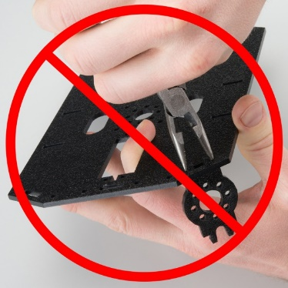](https://cdn.sparkfun.com/assets/learn_tutorials/3/3/7/Redbot_Kit-31_do_not.jpg)

A Note About Directions

When we talk about the “front,” “left,” “right,” and “back” of the Kit, we are referring to specific sides of the robot when viewed from above.

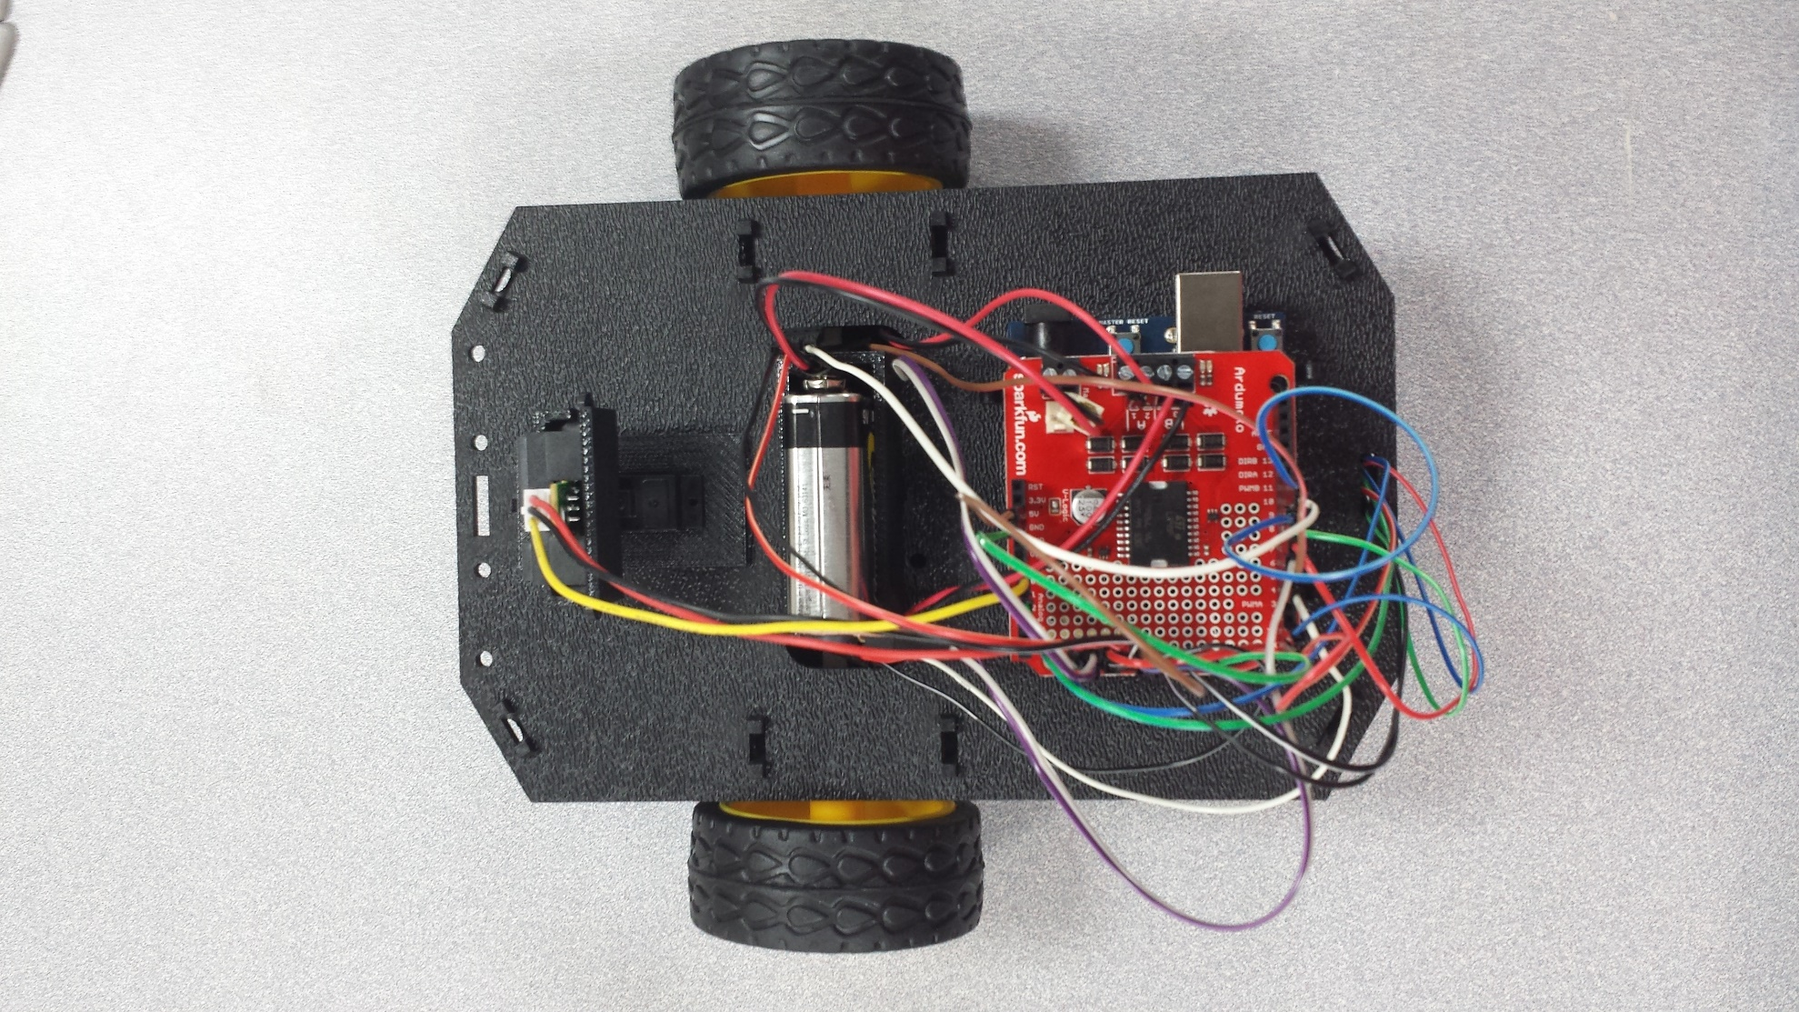

**BACK**

**LEFT**

**RIGHT**

**FRONT**

Notice that we consider the Mainboard to be on the “back” of the Kit and the Proximity Sensor to be in the “front.”

1. Wheel Encoders

The [Wheel Encoder Kit](https://www.sparkfun.com/products/12629) is a simple add-on sensor that can be used to detect how far each wheel rotates. The wheel encoders will allow you to monitor and control the distance the robot travels. The Wheel Encoder Kit uses a [multi-pole diametric ring magnet](http://www.dextermag.com/products/magnets-for-sensors-encoders/multipole-ring-magnets) attached to the motor shaft. As the motor spins, the ring magnet spins as well. This is detected by a small magnetic sensor called a hall effect sensor. The Arduino 101 can use this sensor input to count / track the number of rotations of the motor and hence how far the wheel moves.

**NOTE:** You will likely need some scissors to open the Wheel Encoder Kit. Also, the Encoder Kit might contain some extra parts (e.g. screws and some blue mounting bars). You won’t need those, as the Shadow Chassis contains all the necessary mounting hardware.

(OR if we are giving them the Kits...they will do the install)

The Wheel Encoder Kit is installed in the Encoder Mount and on the Motors. The Shadow Chassis contains all the necessary mounting hardware.

Locate the Following:

|  |  |  |
| --- | --- | --- |
| **1x Bottom Chassis Plate (A)** | **2x Encoder Mount (F)** | **2x Motor (K)** |
| [Bottom Chassis Plate](https://cdn.sparkfun.com/assets/learn_tutorials/3/3/7/Redbot_Kit_Brian_Revisions-13.jpg) | [Encoder Mount](https://cdn.sparkfun.com/r/600-600/assets/learn_tutorials/3/3/7/Redbot_Kit-06.jpg) | [Motor](https://cdn.sparkfun.com/r/600-600/assets/learn_tutorials/3/3/7/Redbot_Kit-11.jpg)C:\Users\dmmanzan\Pictures\20160225_164114.jpg |
| **2x Encoder Magnet Plate (N)** | **2x Encoder Hall Effect Sensor (O)** |  |
| [Encoder Magnet Plate](https://cdn.sparkfun.com/r/600-600/assets/learn_tutorials/3/3/7/Redbot_Kit-16.jpg) | [Encoder Hall Effect Sensor](https://cdn.sparkfun.com/r/600-600/assets/learn_tutorials/3/3/7/Redbot_Kit-17.jpg) |  |

Add the Magnets

Slide the Encoder Magnet Plates (N) onto the metal shaft on the back of the Motors (K). Note that magnet side (silver) should face away from the motor. Slide the magnet down onto the shaft, but make sure that it does not rub or interfere with the back of the motor housing.

Repeat this for both motors.

[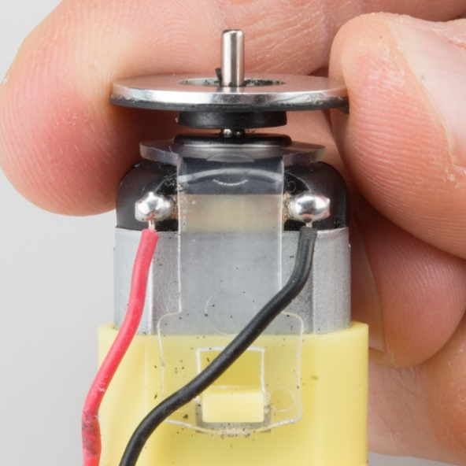](https://cdn.sparkfun.com/assets/learn_tutorials/3/3/7/Redbot_Kit-32.jpg)

Attach the Hall Effect Sensors

Left Encoder

Take one of the Encoder Mounts (F) and hold it so that the protruding slot is on the left. Push one of the encoder sensors through the first slot on the right.

**Note:** The direction of the sensor does not matter.

[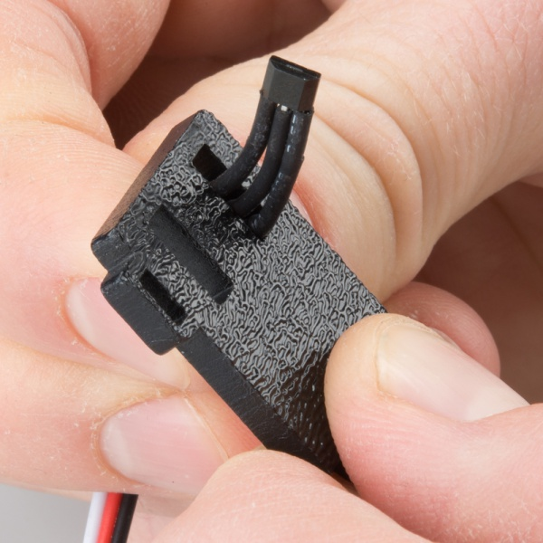](https://cdn.sparkfun.com/assets/learn_tutorials/3/3/7/Redbot_Kit-33.jpg)

Loop the sensor and push it through the second (middle) slot.

[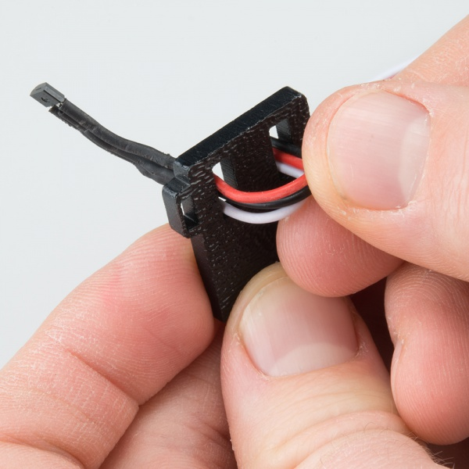](https://cdn.sparkfun.com/assets/learn_tutorials/3/3/7/Redbot_Kit-34.jpg)

Once more, push the sensor through the small protruding slot on the left. Carefully pull the wires so there is no more slack in the mount. Make sure the whole sensor can be seen coming out of the final slot (the sensor should protrude between ¼" and 3/8" past the mount).

[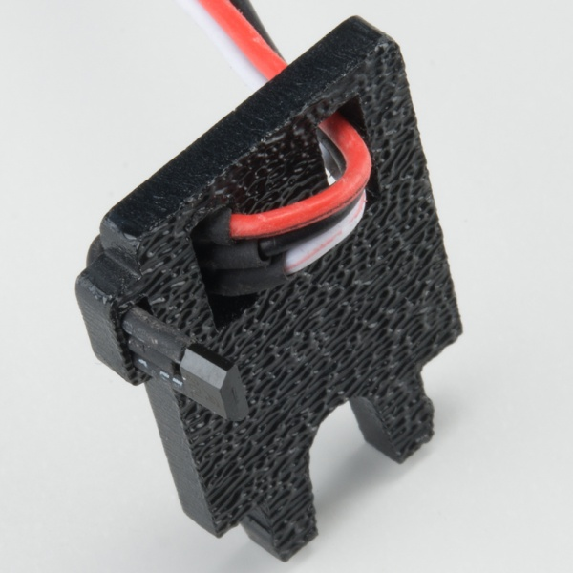](https://cdn.sparkfun.com/assets/learn_tutorials/3/3/7/Redbot_Kit-35.jpg)

Snap the assembled encoder mount into the back-left vertical slot of the Bottom Chassis Plate (A).

[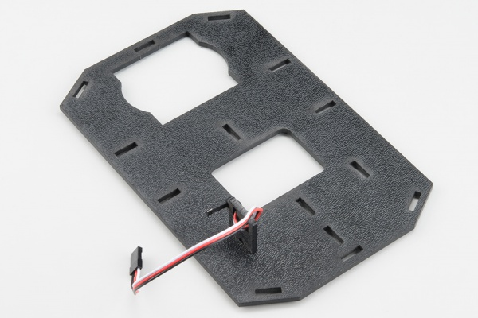](https://cdn.sparkfun.com/assets/learn_tutorials/3/3/7/Redbot_Kit_Brian_Revisions-12.jpg)

Right Encoder

The right encoder is a mirrored assembly of the left encoder.

Take the other Encoder Mount (F) and hold it so that the protruding slot is on the right. Push the other encoder sensor through the first slot on the left.

[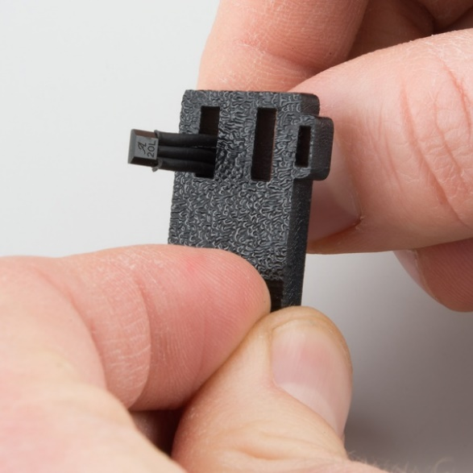](https://cdn.sparkfun.com/assets/learn_tutorials/3/3/7/Redbot_Kit-37.jpg)

Loop the sensor and push it through the second (middle) slot.

[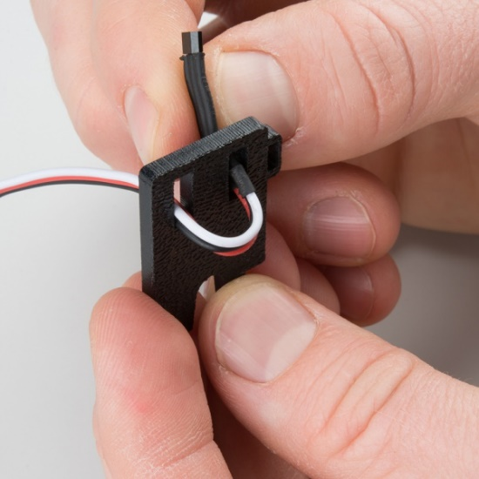](https://cdn.sparkfun.com/assets/learn_tutorials/3/3/7/Redbot_Kit-38.jpg)

Once more, push the sensor through the protruding slot on the right. Carefully pull the wires so there is no more slack in the mount. Make sure the whole sensor can be seen coming out of the final slot (the sensor should protrude between ¼" and 3/8" past the mount).

[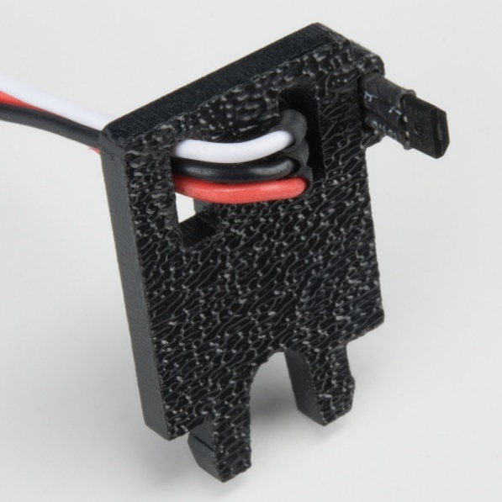](https://cdn.sparkfun.com/assets/learn_tutorials/3/3/7/Redbot_Kit-39.jpg)

Snap the assembled encoder mount into the back-left vertical slot of the Bottom Chassis Plate (A). Note that the hall effect sensors are facing to the outside of the chassis.

[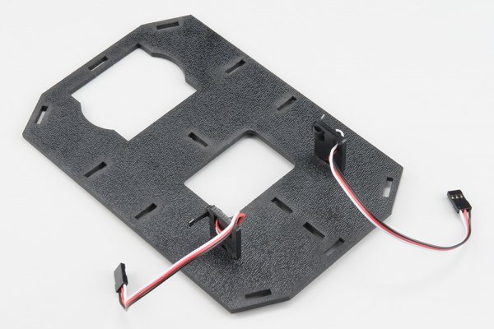](https://cdn.sparkfun.com/assets/learn_tutorials/3/3/7/Redbot_Kit_Brian_Revisions-11.jpg)

2. Motors and Wheels

The motors add some motion to the Kit by turning the nice, rubbery wheels.

**NOTE:** If you completed the previous [Wheel Encoder step](https://learn.sparkfun.com/tutorials/assembly-guide-for-redbot-with-shadow-chassis/1-wheel-encoders-sik), your motors will each have an encoder magnet plate attached to their rear shaft. However, they are not necessary to complete this step.

**ALSO NOTE:** Your motors might not be yellow. Worry not, they will work just as well!

Locate the Following:

|  |  |  |
| --- | --- | --- |
| **2x Front Motor Mount (C)** | **2x Rear Motor Mount (D)** | **2x Motor (K)** |
| [Front motor mount](https://cdn.sparkfun.com/r/600-600/assets/learn_tutorials/3/3/7/Redbot_Kit-04.jpg) | [Rear motor mount](https://cdn.sparkfun.com/r/600-600/assets/learn_tutorials/3/3/7/Redbot_Kit-03.jpg) | [Motor](https://cdn.sparkfun.com/r/600-600/assets/learn_tutorials/3/3/7/Redbot_Kit-11.jpg) |
| **2x Wheel (L)** |  |  |
| [Wheel](https://cdn.sparkfun.com/r/600-600/assets/learn_tutorials/3/3/7/Redbot_Kit-12.jpg) |  |  |

Attach Rear Motor Mounts

Hold the wires near the middle of the Motor (K), and carefully slide a Rear Motor Mount (D) in from the side and over the two motor wires. Be careful not to snag the wires, the cable tie, or the clear plastic strap.

[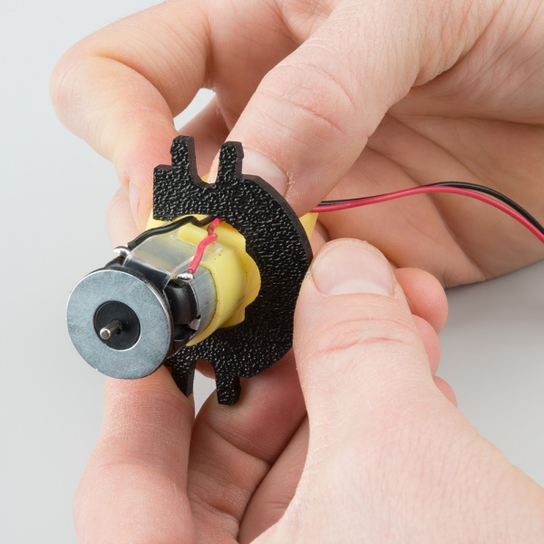](https://cdn.sparkfun.com/assets/learn_tutorials/3/3/7/Redbot_Kit-41.jpg)

Holding the motor wires, gently twist the Rear Motor Mount counter clockwise so that it snaps in place on the motor and the wires are centered in the gap of the motor mount. Again, be sure not to snag the wires under the motor mount.

[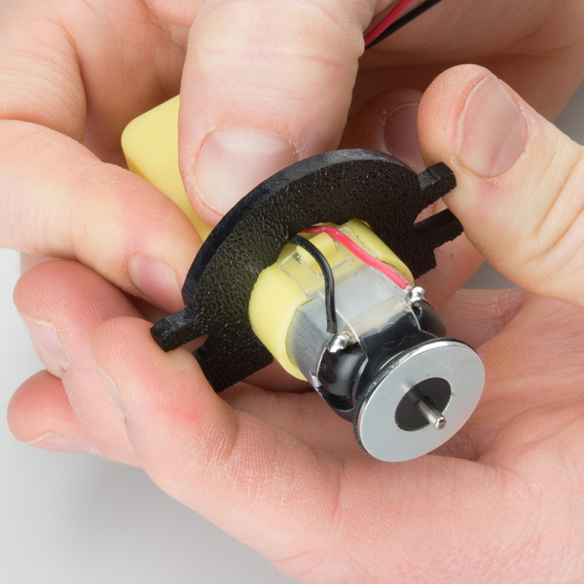](https://cdn.sparkfun.com/assets/learn_tutorials/3/3/7/Redbot_Kit-42.jpg)

Repeat the process for the second motor.

[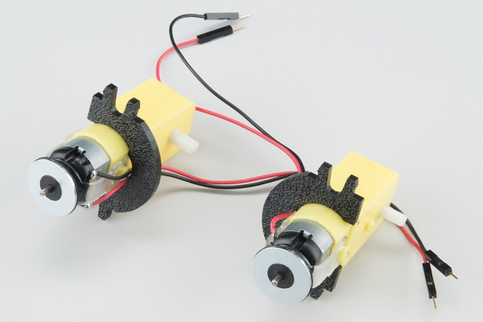](https://cdn.sparkfun.com/assets/learn_tutorials/3/3/7/Redbot_Kit-43.jpg)

Attach the Front Motor Mounts

Slide a Front Motor Mount (C) onto the protruding eyelet on the front of a Motor (K). Ensure the rounded sides of the motor mounts are facing the same way.

[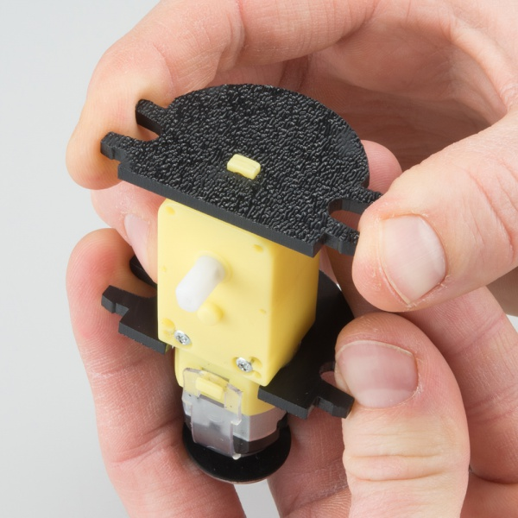](https://cdn.sparkfun.com/assets/learn_tutorials/3/3/7/Redbot_Kit-44.jpg)

Repeat the process for the second motor.

[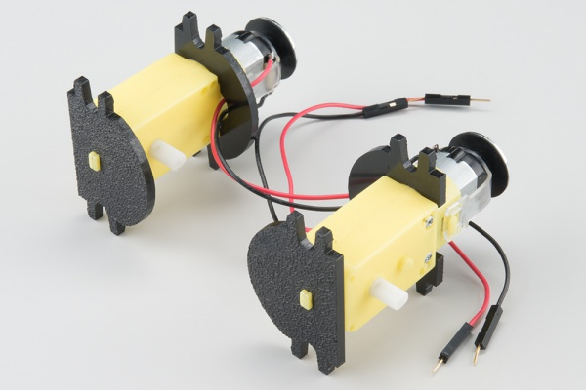](https://cdn.sparkfun.com/assets/learn_tutorials/3/3/7/Redbot_Kit-45.jpg)

Attach the Motor Assemblies to the Chassis

Snap one of the motor assemblies into the left 2 horizontal slots of the Bottom Chassis Plate (A). Make sure that the rounded edges of the motor mounts and the wires are facing toward the center of the chassis.

[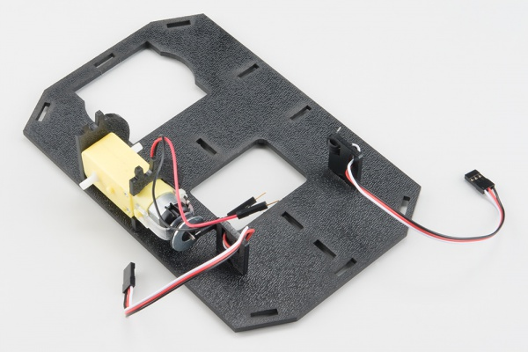](https://cdn.sparkfun.com/assets/learn_tutorials/3/3/7/Redbot_Kit_Brian_Revisions-10.jpg)

Snap the other motor assembly into the right 2 horizontal slots of the Bottom Chassis Plate (A). Again, make sure that the rounded edges of the motor mounts and the wires are facing the center of the chassis.

**NOTE:** Ensure that each mount is completely inserted into the plate chassis.

[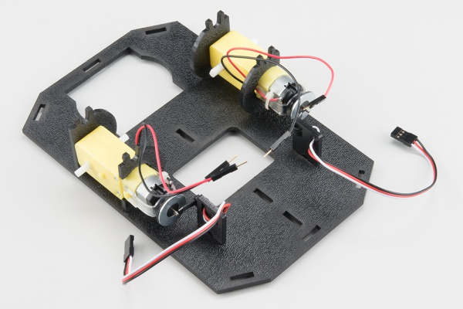](https://cdn.sparkfun.com/assets/learn_tutorials/3/3/7/Redbot_Kit_Brian_Revisions-09.jpg)

**NOTE:** Verify that the Hall Effect sensor is not rubbing against the Magnet (up to a 1/8" away) nor the motor shaft.

Attach the Wheels

Slide one Wheel (L) onto the plastic shaft of a Motor (K). Look at the motor shaft. Notice it has two flat edges. Make sure to line up the flat edges of the motor shaft with the flat edges of the wheel.

[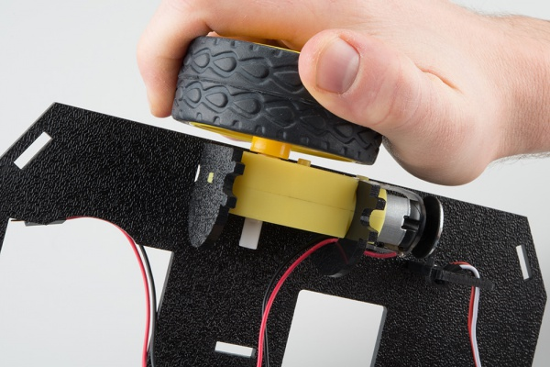](https://cdn.sparkfun.com/assets/learn_tutorials/3/3/7/Redbot_Kit-49.jpg)

Repeat with the other wheel.

[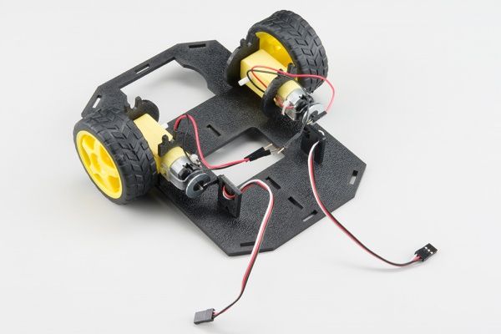](https://cdn.sparkfun.com/assets/learn_tutorials/3/3/7/Redbot_Kit_Brian_Revisions-08.jpg)

3. Line Follower (NOT USED)

4. Mechanical Bumpers (SIK) (NOT USED)

5. Chassis

With the motors and a few sensors attached, we can assemble the main body of the robot.

Locate the Following:

|  |  |  |
| --- | --- | --- |
| **4x Side Strut (E)** | **1x Nub Caster (M)** |  |
| [Side strut](https://cdn.sparkfun.com/r/600-600/assets/learn_tutorials/3/3/7/Redbot_Kit-05.jpg) | [Nub caster](https://cdn.sparkfun.com/r/600-600/assets/learn_tutorials/3/3/7/Redbot_Kit_Reshoot-01.jpg) |  |

You will also need the **Top Chassis Plate** and **Bottom Chassis Plate** assemblies, which have any additional parts and sensors you attached in previous steps.

Attach the Nub Caster

Snap the Nub Caster (M) into the slot on the back of the Bottom Chassis Plate assembly. Make sure the Nub Caster is on the side opposite the motors (the bottom side).

[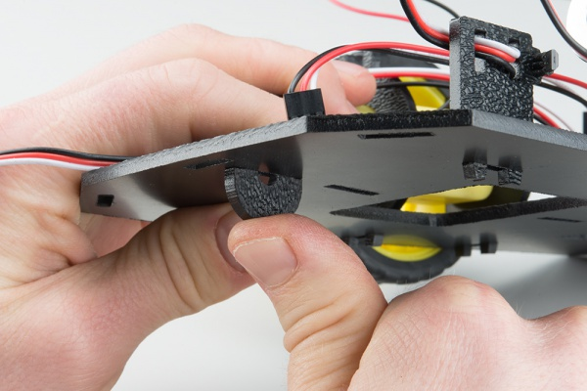](https://cdn.sparkfun.com/assets/learn_tutorials/3/3/7/Redbot_Kit_Reshoot-02.jpg)

Add the Side Struts

Snap the four Side Struts (E) into the diagonal slots on the four corners of the Bottom Chassis Plate assembly. 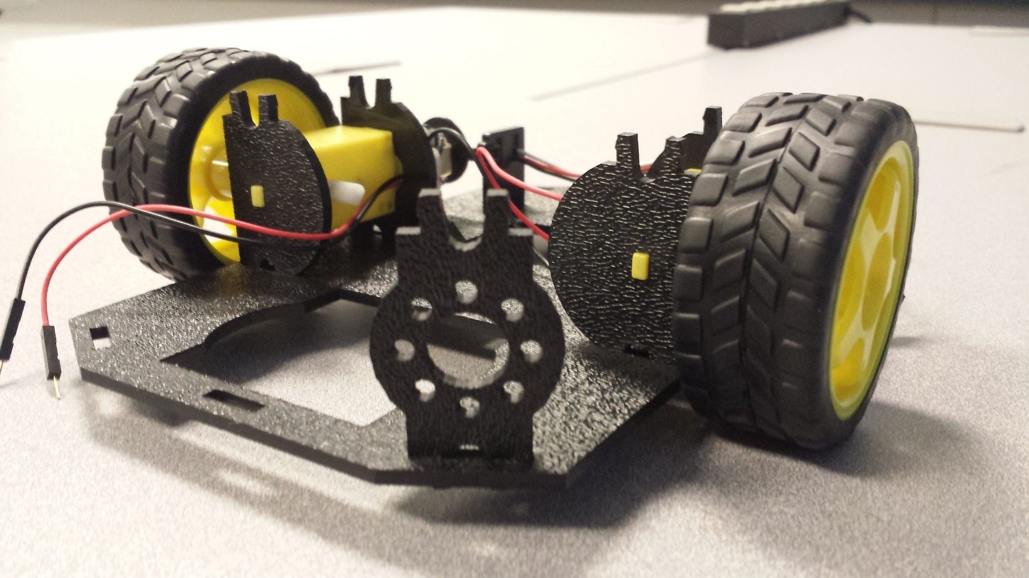

Route the Cables

Position the Top Chassis Plate over the Bottom Chassis Plate – but do not snap the two plates together yet. Make sure that the front sides of each plate line up.

Route the wires and cables through the left and right oval slots in the Top Chassis Plate assembly as shown.

**Cable Routing:**

|  |  |
| --- | --- |
| **Cable Connection** | **Oval Side** |
| Left Motor wires (red and black) | Left |
| Right Motor wires (red and black) | Right |
| Left Wheel Encoder | Left |
| Right Wheel Encoder | Right |
|  |  |

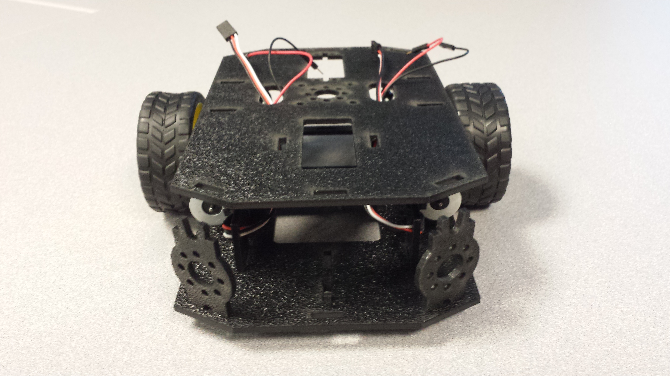

Attach Top Chassis Plate Assembly

Line up the Top Chassis Plate on top of all the struts, and carefully snap the Top Chassis Plate assembly onto the side struts and motor mounts. Press gently above each side strut individually until they each snap into place.

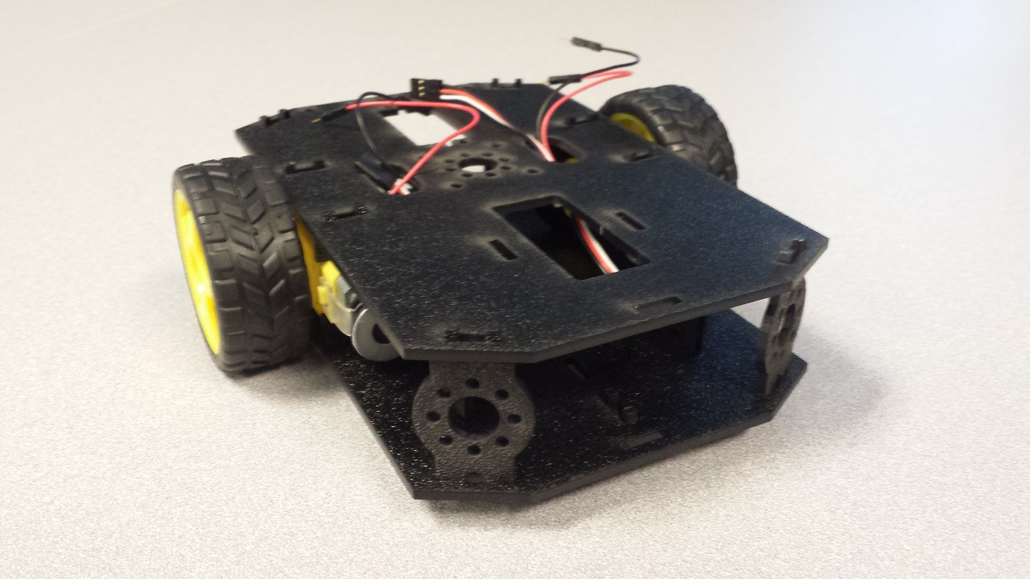

If you need to remove the plate to change anything, gently pull upward on each side strut individually. Do not attempt to use pliers or hand tools, or you may end up snapping the plastic clip.

6. Mainboard

In this section, you will add brains of the robot: the Arduino 101.

Locate the Following:

|  |  |  |
| --- | --- | --- |
| **2x Mainboard Mount (G)** | **1x Arduino 101 (P)** | **1 x Ardumoto Shield** |
| [Mainboard mount](https://cdn.sparkfun.com/r/600-600/assets/learn_tutorials/3/3/7/Redbot_Kit-07.jpg) | Product Image | Product Image |

You will also need the full chassis assembly, which contains any additional parts you attached in previous steps.

Attach the Mainboard Mounts

Snap the two Mainboard Mounts (G) into the vertical slots in the back of the top chassis plate near the large rectangular opening.

[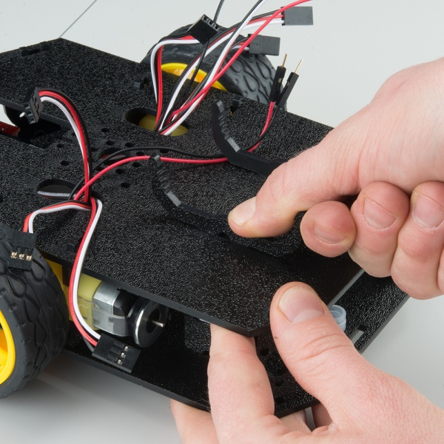](https://cdn.sparkfun.com/assets/learn_tutorials/3/3/7/Redbot_Kit-70.jpg)

Add the Mainboard

The Arduino 101 Mainboard (P) snaps into the notches on the Mainboard Mounts (G) it will not be down to the lowest notch. Make sure the power jack is facing the left side of the robot (the Mainboard mounts should be closest to you). Push gently and evenly until it snaps into place.

NOTE: While applying downward pressure to the board, gently expand one of the mount legs, and repeat on the other until the mainboard is securely held in the Mainboard Mounts (the Mainboard should not move in the mounts).

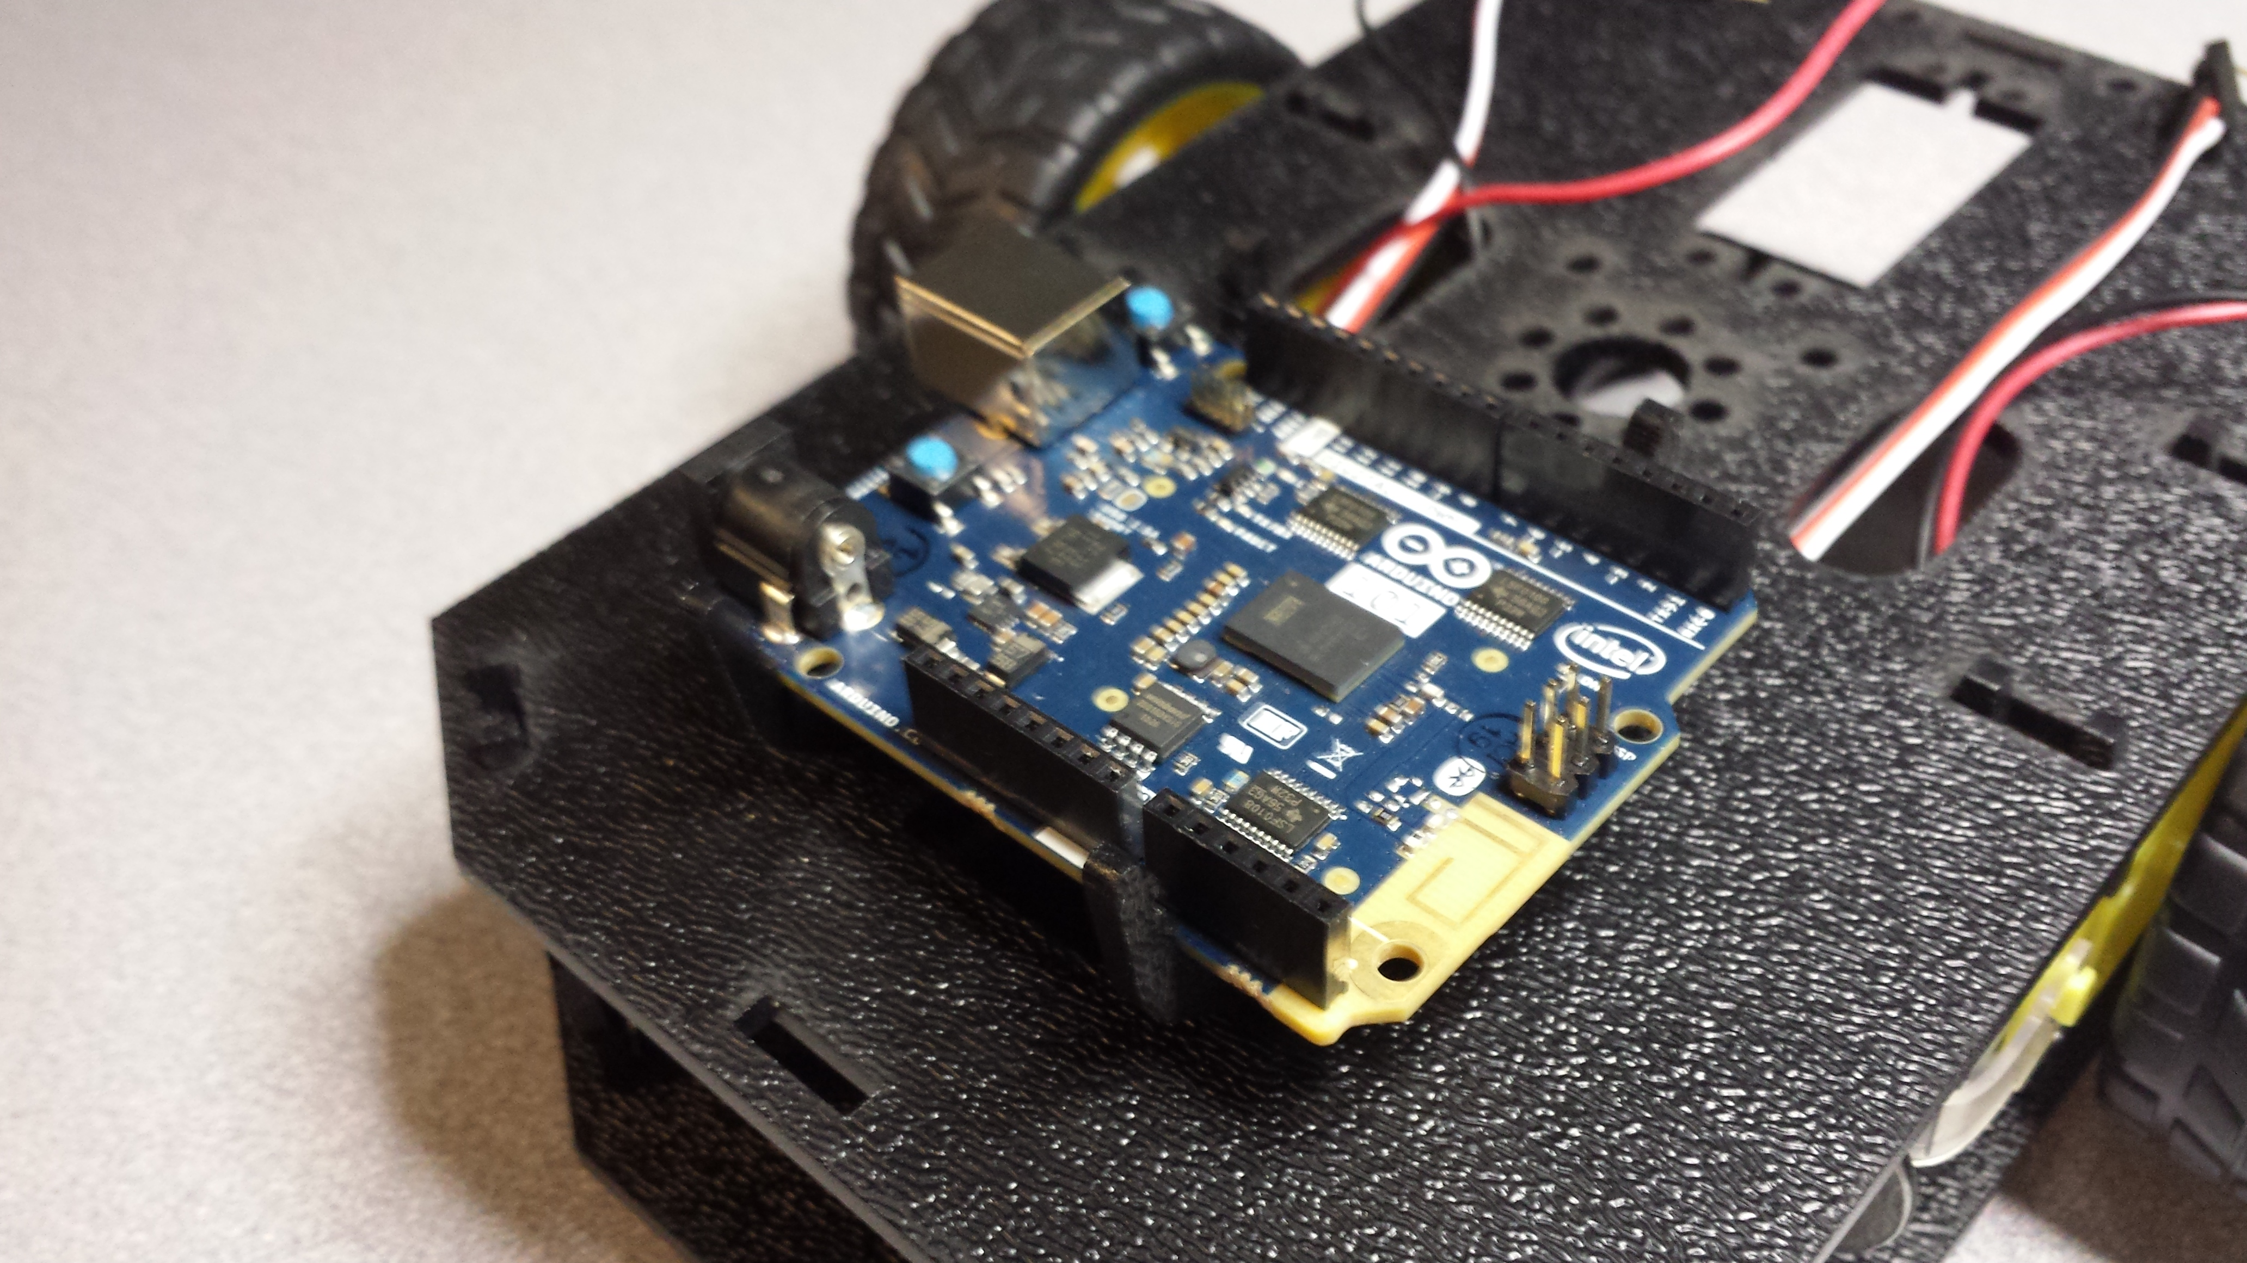

Connecting the Cables (NEEDS EDITING based on SHIELD choice)

It is time to connect the jumper wires; it is really important that these connections are correct.

You can follow along with the pin out tables or scroll down for a diagram. Trace each cable poking through the top chassis plate to make sure you know what it is connected to.

**Please note:** When you have the RedBot upright and the front of the chassis facing away from you, “left” sensors/motors will be on the left side and “right” sensors/motors will be on the right side. Also - the motor wires are intentionally switched for the right motor – see notes below.

[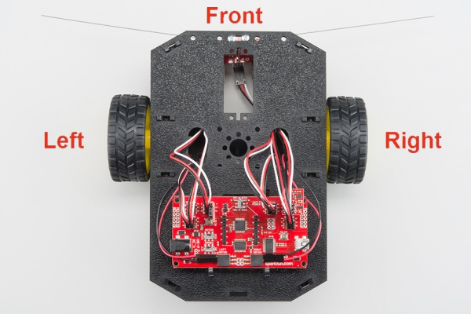](https://cdn.sparkfun.com/assets/learn_tutorials/3/3/7/Redbot_Kit_Brian_Revisions-01.jpg)

Wire Connections of Motors, Encoders, RGB LEDs

Motors

**Left Motor:**

|  |  |
| --- | --- |
| **RedBot Mainboard Pins** | **Left Motor Jumper Wires** |
| LEFT MOTOR - RED | Soldered on Motor Jumper Wire - RED |
| LEFT MOTOR - BLACK | Soldered on Motor Jumper Wire - BLACK |

**\*Right Motor:**

|  |  |
| --- | --- |
| **RedBot Mainboard Pins** | **Right Motor Jumper Wires** |
| RIGHT MOTOR - RED | Soldered on Motor Jumper Wire - BLACK |
| RIGHT MOTOR - BLACK | Soldered on Motor Jumper Wire - RED |
| **Note that these are reversed!** We need to plug the red wire into the port marked "BLACK" and the black wire into "RED." This is because the new Shadow Chassis motors were wired backwards (not mirrored). | |

Motor Encoders

**Left Wheel Encoder (SIK):**

|  |  |  |
| --- | --- | --- |
| **RedBot Mainboard Pins** | **Jumper Wires** | **Left Wheel Encoder** |
| A2 | 3-Wire Jumper Cable - White | OUT |
| POW | 3-Wire Jumper Cable - Red | 5V |
| GND | 3-Wire Jumper Cable - Black | GND |

**Right Wheel Encoder (SIK):**

|  |  |  |
| --- | --- | --- |
| **RedBot Mainboard Pins** | **Jumper Wires** | **Right Wheel Encoder** |
| 10 | 3-Wire Jumper Cable - White | OUT |
| POW | 3-Wire Jumper Cable - Red | 5V |
| GND | 3-Wire Jumper Cable - Black | GND |

Diagram

[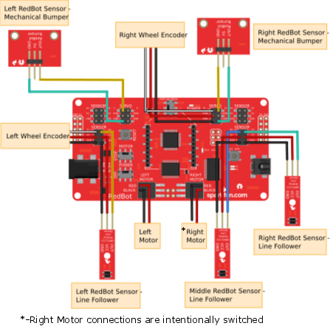](https://cdn.sparkfun.com/assets/learn_tutorials/3/3/7/redbot_all_parts_rev_motors_right2.png)

Note: The connections on the right motor are intentionally switched. See the note above.

*Having a hard time seeing the image? Click on the image to see a bigger diagram.*

7. Accelerometer (Intel Curie IMU)

8. Buzzer

**Read on if you have the**[**SIK for RedBot**](https://www.sparkfun.com/products/12649)**or are using the**[**RedBot Buzzer**](https://www.sparkfun.com/products/12567)**. If not, skip to the next section.**

Every robot should be able to make some sounds. Adding the buzzer will allow you to give your RedBot a little personality with its own beeps and bops. Adding the RedBot Buzzer is nice and easy!

Locate the Following:

|  |  |  |
| --- | --- | --- |
| **1x Buzzer Board (S)** |  |  |
| [RedBot Buzzer](https://cdn.sparkfun.com/r/600-600/assets/learn_tutorials/3/3/7/Redbot_Kit-21.jpg) |  |  |

Add the RedBot Buzzer

Locate the SERVO port with “9” marked on the RedBot Mainboard. With the buzzer and female header side of the Buzzer Board (S) facing to the left, place the Buzzer Board on top of the “9”, “POW”, and “GND” male header pins.

[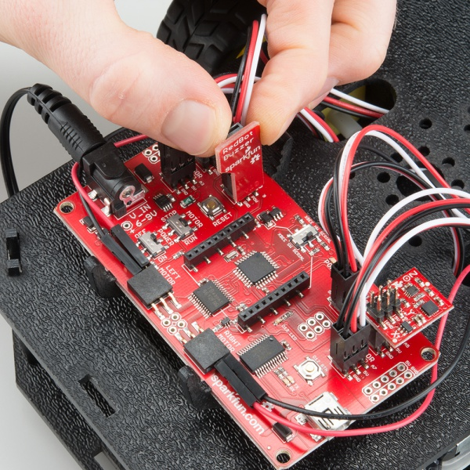](https://cdn.sparkfun.com/assets/learn_tutorials/3/3/7/Redbot_Kit_Brian_Revisions-05.jpg)

9. Batteries

The last step is to provide a power source for the RedBot. If you do not have the SIK for RedBot, you will need to provide your own AA batteries.

Locate the Following:

|  |  |  |
| --- | --- | --- |
| **1x Battery Pack Clip (H)** | **1x Battery Holder (Z)** | **4x AA Batteries* (AA)** |
| [Battery pack clip](https://cdn.sparkfun.com/r/600-600/assets/learn_tutorials/3/3/7/Redbot_Kit-08.jpg) | [Battery pack](https://cdn.sparkfun.com/r/600-600/assets/learn_tutorials/3/3/7/Redbot_Kit-28.jpg) | [Battery](https://cdn.sparkfun.com/r/600-600/assets/learn_tutorials/3/3/7/Redbot_Kit-29.jpg) |
| * Provided in the SIK for RedBot | | |

Insert Batteries

Insert the AA batteries into the Battery Holder (Z). Makes sure the batteries are facing the correct direction, as per the markings inside of the Battery Holder.

[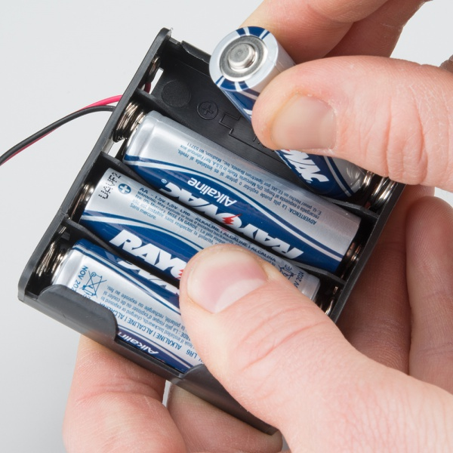](https://cdn.sparkfun.com/assets/learn_tutorials/3/3/7/Redbot_Kit-75.jpg)

Attach Battery Pack

Insert the Battery Holder (Z) with batteries into the back cavity of the RedBot. Position the Battery Holder so that the barrel jack cable comes out on the left side of the robot.

[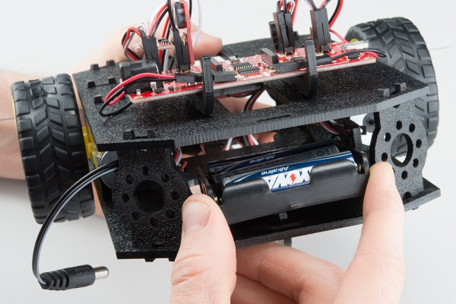](https://cdn.sparkfun.com/assets/learn_tutorials/3/3/7/Redbot_Kit_Reshoot-04.jpg)

Insert the Battery Pack Clip (H) on top of the battery pack.

[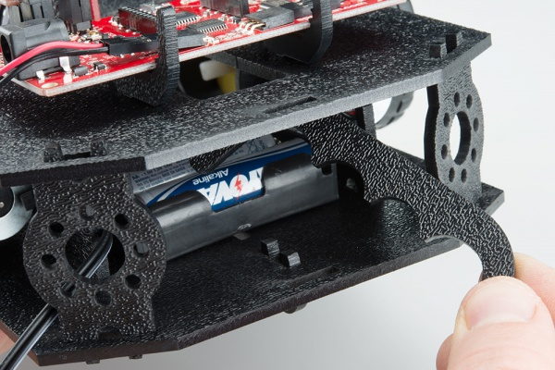](https://cdn.sparkfun.com/assets/learn_tutorials/3/3/7/Redbot_Kit_Reshoot-05.jpg)

Twist and position the clip so that it rests on top of the battery pack.

[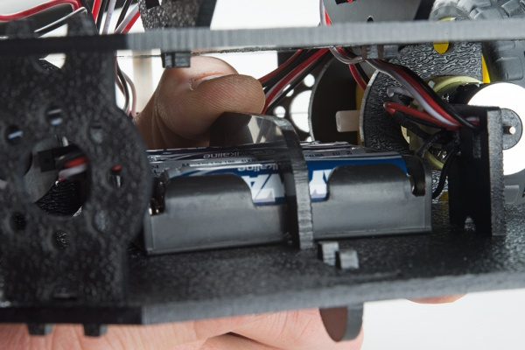](https://cdn.sparkfun.com/assets/learn_tutorials/3/3/7/Redbot_Kit_Reshoot-06.jpg)

Push the clip down into the vertical slots in the Bottom Chassis Plate so it snaps in place.

[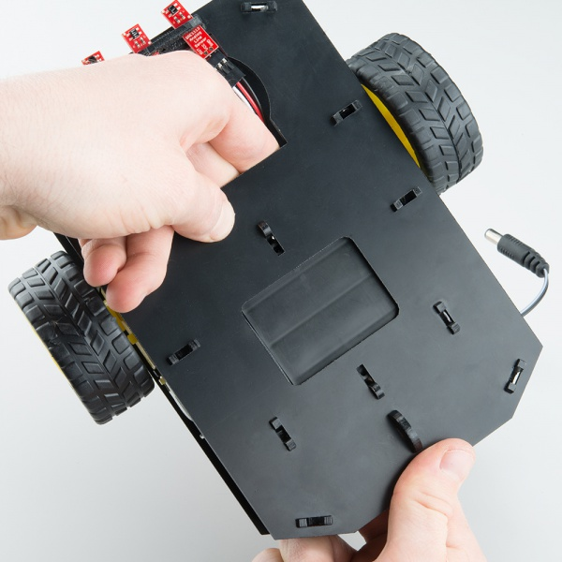](https://cdn.sparkfun.com/assets/learn_tutorials/3/3/7/Redbot_Kit_Reshoot-07.jpg)

Route the barrel jack cable out of the left side of the RedBot and up to the Mainboard. If you have a motor encoder (SIK), make sure that the cable does not interfere with the magnet or the hall effect sensor.

Plug the barrel jack cable into the connector labeled **V_IN**.

[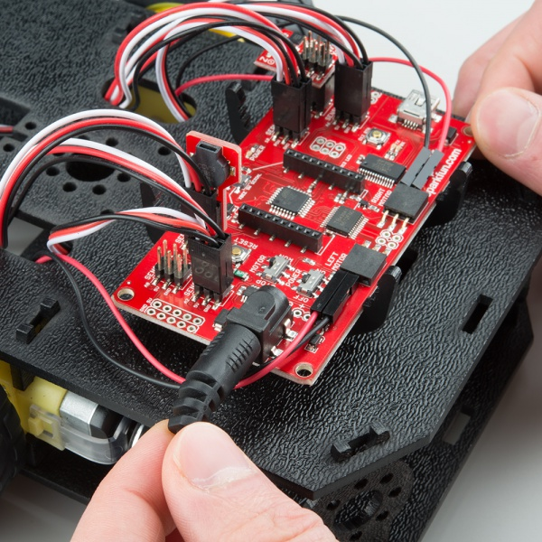](https://cdn.sparkfun.com/assets/learn_tutorials/3/3/7/Redbot_re-wired_shots-03.jpg)

Changing the Batteries

If you find that you need to replace the batteries in the RedBot, the process is simple. Unplug the battery pack from the Mainboard.

[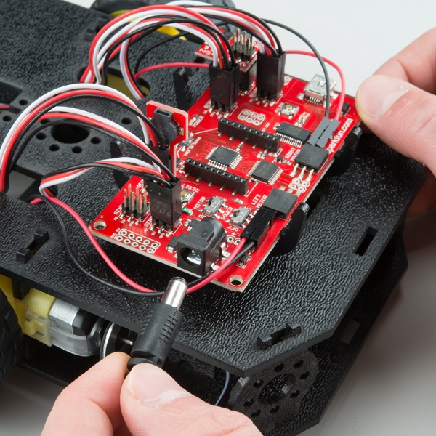](https://cdn.sparkfun.com/assets/learn_tutorials/3/3/7/Redbot_re-wired_shots-02.jpg)

Turn the RedBot over and push on the Battery Holder through the hole in the Bottom Chassis Plate. This will cause the Battery Pack Clip to unsnap from the Bottom Chassis Plate.

[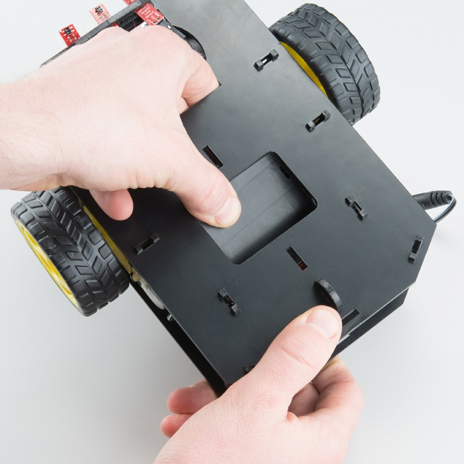](https://cdn.sparkfun.com/assets/learn_tutorials/3/3/7/Redbot_Kit_Reshoot-10.jpg)

Slide the Battery Pack and Clip out from the back of the RedBot.

[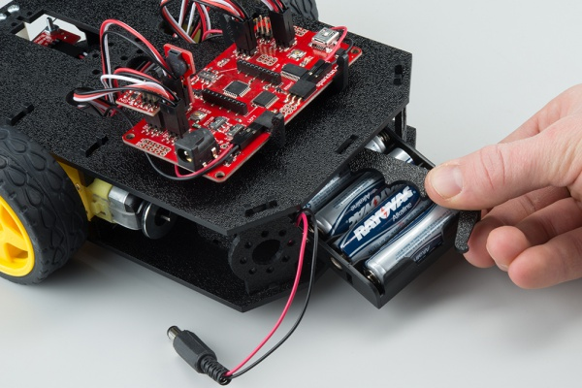](https://cdn.sparkfun.com/assets/learn_tutorials/3/3/7/Redbot_Kit-84.jpg)

Change the batteries, and follow the steps in *Attach Battery Pack* section above to put the Battery Pack back in the RedBot.

10. Run It!

Now that we have built the RedBot, we should verify that it works. If you would like a more in-depth explanation of how to program your robot, visit the [Experiment Guide for RedBot with Shadow Chassis](https://learn.sparkfun.com/tutorials/experiment-guide-for-redbot-with-shadow-chassis). This will work with the [RedBot Basic Kit](https://www.sparkfun.com/products/13166) as well as the [RedBot SIK](https://www.sparkfun.com/products/12649).

Install Drivers

To program your robot right from your browser, you will first need to install some FTDI drivers. Follow the steps in [How to Install FTDI Drivers](https://learn.sparkfun.com/tutorials/how-to-install-ftdi-drivers) to do that.

Install Codebender Plugin

You will need [Google Chrome](http://www.google.com/chrome/) or [Firefox](https://www.mozilla.org/en-US/firefox/new/) as a browser for the plugin to work. If you do not have either of those and do not wish to install them, you should follow the steps in the [Experiment Guide](https://learn.sparkfun.com/tutorials/experiment-guide-for-redbot-with-shadow-chassis) to program the RedBot from the [Arduino](http://www.arduino.cc/en/Main/Software)software.

Click here to install the [Codebender Plugin](https://codebender.cc/static/plugin) for your Chrome or Firefox.

Power the RedBot

To program the RedBot from your browser, make sure you have the [FTDI drivers](https://learn.sparkfun.com/tutorials/how-to-install-ftdi-drivers) and Codebender [plugin](https://learn.sparkfun.com/tutorials/assembly-guide-for-redbot-with-shadow-chassis/(https:/codebender.cc/static/plugin)) installed. Plug in the RedBot using a [USB mini cable](https://www.sparkfun.com/products/11301).

[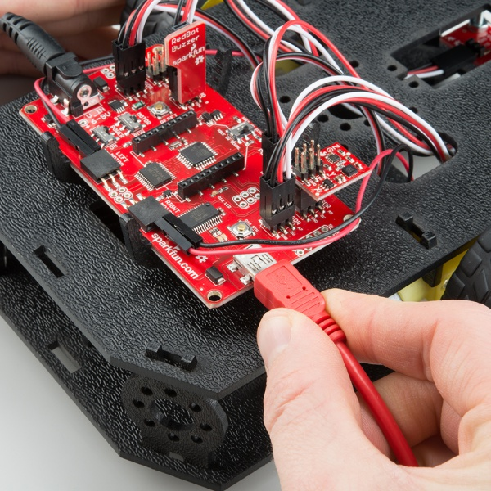](https://cdn.sparkfun.com/assets/learn_tutorials/3/3/7/Redbot_Kit_Brian_Revisions-06.jpg)

Turn the RedBot POWER switch to ON and the MOTOR switch to RUN.

[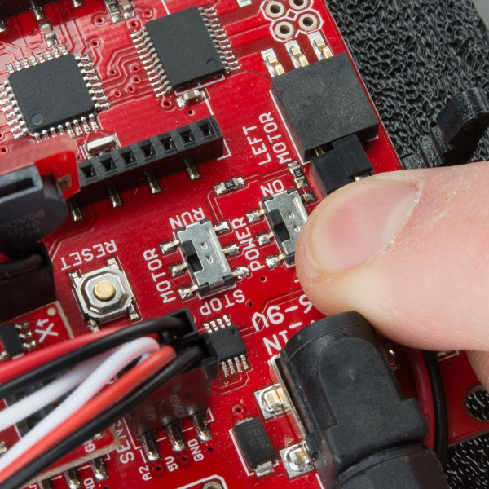](https://cdn.sparkfun.com/assets/learn_tutorials/3/3/7/Redbot_Kit-87_post.jpg)

Test Some Code

In the window above, select “Arduino UNO” for the board. Select COM port for the RedBoard (this will be the number or name that appears when you plug in the RedBoard).

[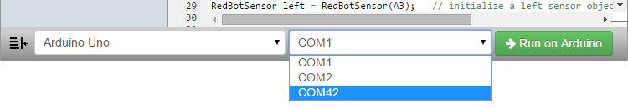](https://cdn.sparkfun.com/assets/learn_tutorials/3/3/7/Screen-01.png)

Click the “Run on Arduino” button. The code should be pushed to the Arduino automatically.

**WARNING:** If the MOTOR switch is set to RUN, the RedBot will move forward (quite rapidly) for 2 seconds. You might want to pick the RedBot up so that it doesn’t run away from you!

The RedBot will drive forward for only 2 seconds and then stop. If you want to run the code again, you will need to press the RESET button on the RedBot Mainboard.

Resources and Going Further

What a rock star! With all that building, we bet you are ready to start cruising. We recommend continuing to the[Experiment Guide for RedBot with Shadow Chassis](https://learn.sparkfun.com/tutorials/experiment-guide-for-redbot-with-shadow-chassis) to learn how to program your new robot friend.

[Experiment Guide for RedBot with Shadow Chassis](https://learn.sparkfun.com/tutorials/experiment-guide-for-redbot-with-shadow-chassis)

This Experiment Guide offers nine experiments to get you started with the SparkFun RedBot. This guide is designed for those familiar with our SparkFun Inventors Kit and want to take their robotics knowledge to the next level.

Upgrades

You might have noticed some odd-looking hole patterns in the top plate and side struts. The RedBot’s chassis is manufactured to accept [Actobotics](https://www.sparkfun.com/pages/Actobotics) parts. Feel free to add other mounts, gimbals, servos, and claws!

[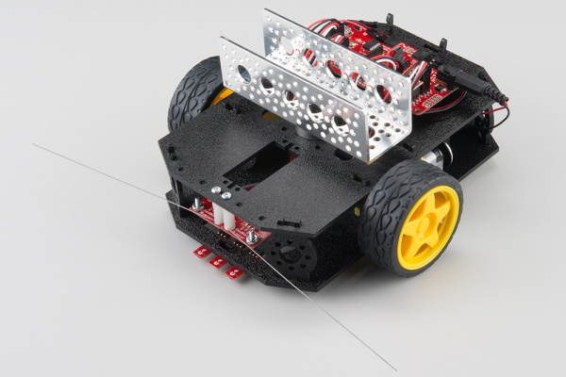](https://cdn.sparkfun.com/assets/learn_tutorials/3/3/7/Redbot_Kit-92.jpg)

Resources

GitHub repositories:

* [RedBot](https://github.com/sparkfun/RedBot)
* [RedBot with Optical Encodery](https://github.com/sparkfun/RedBot_with_Optical_Encoder)
* [RedBot Accelerometer](https://github.com/sparkfun/RedBot_Accelerometer)
* [RedBot Line_Sensor](https://github.com/sparkfun/RedBot_Line_Sensor)
* [RedBot Whisker Bumper](https://github.com/sparkfun/RedBot_Whisker_Bumper)
* [RedBot Buzzer](https://github.com/sparkfun/RedBot_Buzzer)

# Arduino IDE

https://www.arduino.cc/en/Main/Software

Bottom of Form

**SparkFun** is an online retail store that sells the bits and pieces to make your electronics projects possible. Whether it's a robot that can cook your breakfast or a GPS cat tracking device, our products and resources are designed to make the world of electronics more accessible.

In addition to products, SparkFun also offers classes and online tutorials to help educate individuals in the wonderful world of embedded electronics.